Sounds of Intent Charity

Equality, Diversity and Inclusion Policy

1. Context
Sounds of Intent Charity seeks to promote of the education and wellbeing of children, young people and adults through investigating, researching, developing and promoting educational, therapeutic and recreational strategies and resources that support and encourage the creative and aesthetic development of such people through the performing arts and in particular their understanding and appreciation of and engagement with music. The Charity expects every adult working with or for it to support the policy and to comply with it.
- The Policy
The Trustees of Sounds of Intent recognise their responsibilities under the Equality Act 2010 and are opposed to all forms of discrimination. They seek to create an environment in which diversity and the contributions of all staff, volunteers and other professionals, beneficiaries, potential beneficiaries and their families are recognised and valued in all that they do.

No staff, volunteer, other professional, beneficiary or potential beneficiary will be discriminated against either directly or indirectly on the grounds of race, colour, religion, nationality, ethnic origin, gender, disability, age, sexual orientation or identity.

Sounds of Intent Ccharity actively seeks to make its activities and research outcomes accessible to people from all backgrounds through freely publishing and distributing educational resources developed by the charity, and through links with other organisations.

Sounds of Intent Charity will treat seriously all complaints under this policy made by staff, volunteers, families, other professionals or third parties and will take appropriate action. All complaints will be investigated in accordance with the Complaints and Compliments Policy, as appropriate and the complainant will be informed of the outcome in line with these procedures.

This policy is reviewed regularly and updated as required.

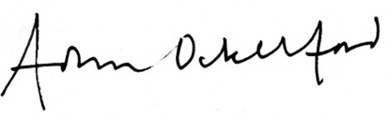

Adam Ockelford
Chair, Sounds of Intent Charity
v1.4, May 2022

